CHAPTER 11

Resonance and the stability of the Solar System

Introduction

The Earth is a special place and we are blessed with laws of physics, chemistry and biology that are just perfect for life to have evolved and to exist so beautifully as it does today. Of course we are busy messing it all up, but that’s another story. The Moon is responsible to giving us tides and the story of how the moon came to be is the subject of a great book called “The Big Splat” by Dana Mackenzie (fig. 1).

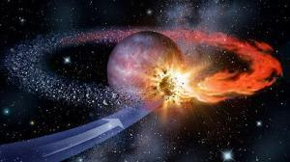

Fig. 1. The moon came to be after a rogue Mars-sized planet (called Theia) collided with the Earth. OUP: NOT SURE WHERE THIS IMAGE IS FROM

The moon, it seems, is important to us in so many ways. I have often wondered if it is a coincidence that the size of the Sun and Moon are identical – so as to allow annular and total eclipses. Maybe this isn’t a coincidence, but I can’t quite think of a good explanation. It would have been good to talk with Archie about it …

A number of recent articles and television programmes have stated that the Earth’s axis would fluctuate widely without the moon to stabilise it, and that this means that planets without a large moon in other solar systems would be unlikely to support life. At first sight this seems implausible given that an isolated Earth will not change its axis of rotation (by conservation of angular momentum) and that the first effect of a moon would be to destabilise the axis by causing precession. Furthermore, life is remarkably adaptable, and since at least primitive organisms mutate pretty rapidly, any changes in a planet’s axis over millions of years might stimulate rather than extinguish life.

But nothing is ever simple and it is true that the moon could help to stabilise the Earth’s axis. The Earth and moon are a coupled system with a combined conserved angular momentum, so that changes in the axis of the Earth would require changes in the moon’s orbit, which would make such changes more difficult. However, this avoids the real question of what forces could change the axis of the Earth and moon together and lead to rapid (i.e. over a period of a few million years) and chaotic changes in the Earth’s axis (1).

Changes of the direction of the Earth’s spin axis gives rise to the Precession of the Equinoxes. The direction of the spin axis can only change if there is some kind of torque acting on the Earth. If the Earth were a sphere, its symmetry means that no gravitational force can exert a torque. However, the Earth bulges at the equator due to centrifugal force. Even so, a uniform gravitational force on a bulged Earth (called an oblate spheroid) will exert no torque. But gravity from the sun isn’t uniform on account of the inverse square law. There is a gradient in force so that one side of the bulge experiences a different force from the other. Given this combination of second order effects, it is very surprising to find that the calculations of the stability of the axis have to include not only the gravitational force the Sun but also of Jupiter and its gradient. There are two reasons for this. One is that any gravitational system of more than two bodies is inherently chaotic (known as “the three-body problem”). This seems to have two slightly different meanings. One is that very small variations in initial conditions can lead to great variations in the orbits of the bodies and can predict planets being ejected from the solar system or crashing into each other. However, it is also used for the less dramatic effect that the basic orbits remain stable but the position of the planet in it is not predictable. The latter meaning is just a result of the inaccuracy of the numerical solution of differential equations in time steps starting from the initial position and velocity. To predict the evolution of the solar system, equations must be solved over a timeframe of billions of years, and this will tax even a modern supercomputer.

Resonance

Central to these effects is the concept of resonance. The principle is familiar. A pendulum clock works with great accuracy on account of resonance. And if you make a loud sound at a particular frequency in a building then any room nearby with the same natural frequency will start to vibrate as well, and we hear the resonance. A wine glass can be shattered by a strong soprano voice. It also works for multiple frequencies. If you shout ‘aah’ at the strings of a piano (with the pedal down) they will reply ‘aah’ and if you shout ‘boo’ it will reply ‘boo’. In general, if two effects have the same period and the damping is low, then a very small interaction can transfer energy from one system to the other.

Coupled Pendulums
To put some quantitative flesh on these bones it is worth analysing numerically a simple system that has a number of general applications. These applications extend across a very wide range of physics.

Take two isolated pendulums each with a natural frequency ω_{ο} (fig. 2). Equating the gravitational force to the angular acceleration leads to the simple harmonic equation for each:

Now consider two such pendulums, for example mounted on a board, with a small interaction between them so that there is a moment kθ from one to the other. Then the equations of motion are:

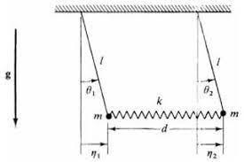
Fig. 2. A coupled pair of pendulums.
OUP; Diagram needs improving

We now postulate a harmonic solution varying as sin(ωt) for both angles θ.

Then

These are homogeneous equations and only have a solution other than zero amplitudes if they are linearly dependent. Then the ratio of amplitudes is determined, but the absolute values remain arbitrary.

For a solution:

there are two possible resonant frequencies:

These correspond to normal modes θ₁ =θ₂ or θ₁ = −θ₂.

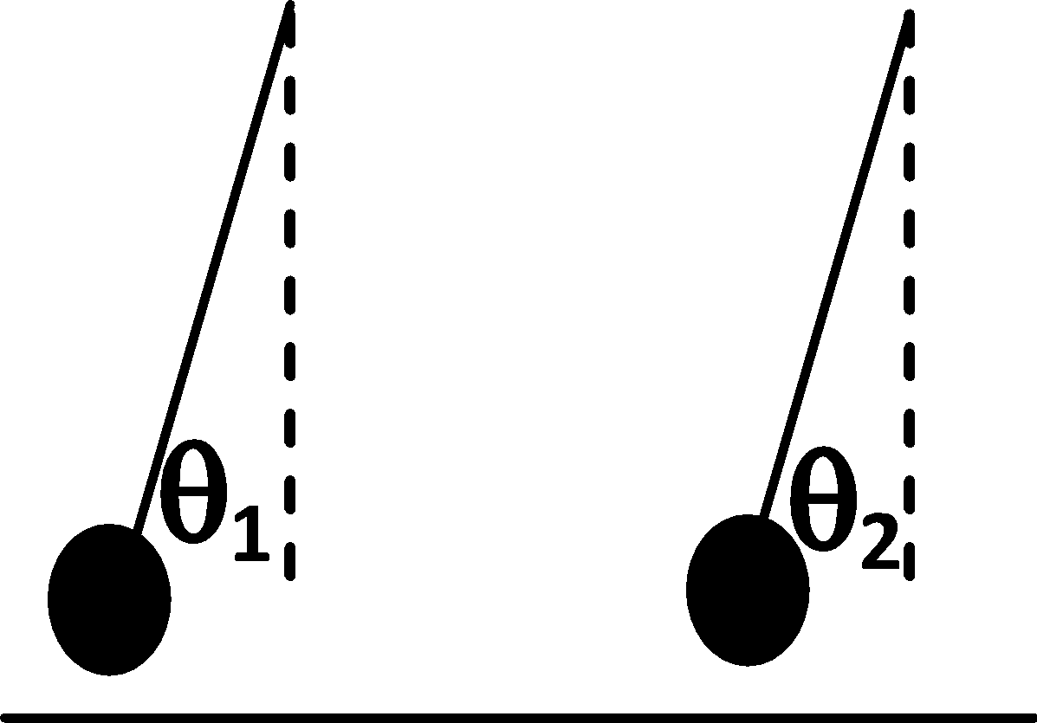 | 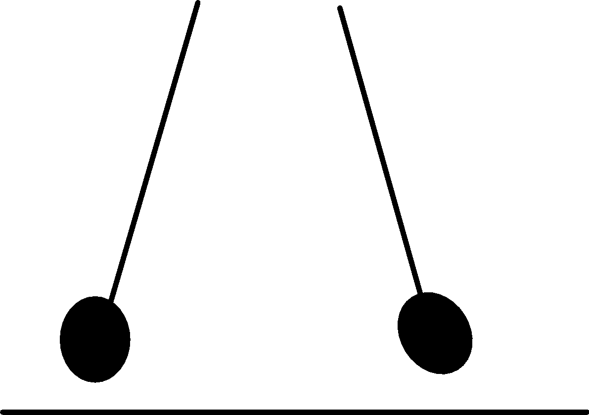 | 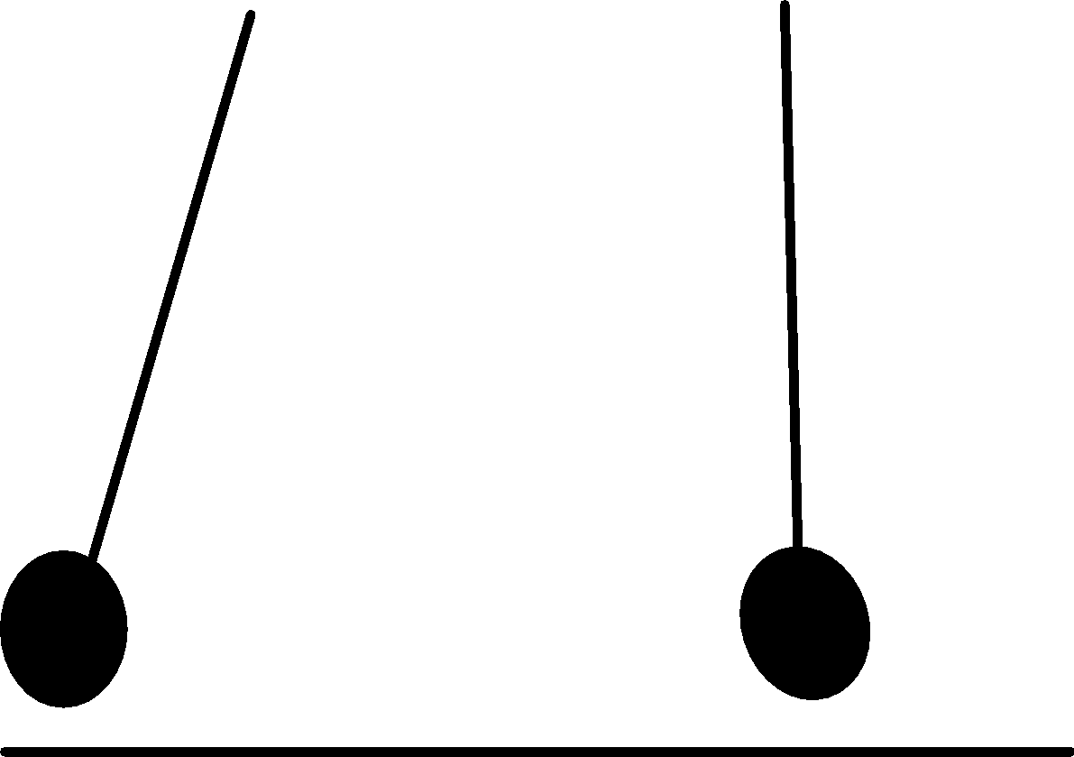
(a) | (b) | (c)

Fig. 3. (a) mode 1, ω=√(ω_{o}²–k), (b) mode 2, ω=√(ω_{o}²+k) and (c) The sum of modes 1 and 2.

Figures 3(a) and (b) show the two solutions. In (a), the pendulums move in phase, and in antiphase in (b). Both of these motions will continue indefinitely without change. However, Fig. 3(c) shows the situation of interest where one pendulum is initially stationary, and we start the other one moving. Clearly, this will begin to make the second pendulum oscillate. To find how this develops we add the two normal modes of Figs 3(a) and (b).

These modes are:

A and B are arbitrary amplitudes. To obtain the solution where the second pendulum starts at rest, we add solutions with A= θ_{o}/2 where θ_{o} is the amplitude of the moving pendulum.

Then:

Now we assume the coupling is small, so k is small. Then ω₁–ω₂ = δω = k/ω_{o}².

The solution is:

We see that if we start the pendulum on the left at t=0 with an amplitude θ_{o}, the stationary pendulum on the right will gradually pick-up amplitude while the amplitude of the pendulum on the left decreases to conserve energy. After a time t = π/2δω = πω_{ο} /2k, all the energy has been transferred from one pendulum to the other. This then repeats at the beat frequency of the two normal modes, each pendulum comes to rest in turn while the other reaches a maximum. For this to occur the starting point must be as Fig. 3(c) and the periods of the pendulums need to be identical. However, no matter how low the coupling, if there is no damping, eventually all the energy is transferred. This is an easy experiment to set up with some string and a couple of apples (fig. 4).

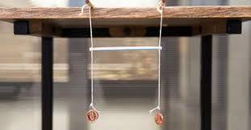

Fig. 4. A coupled pendulum experiment with string and coins. OUP: NOT SURE WHERE THIS IMAGE IS FROM

The solar system is much more complicated, although the same principles apply. Whenever there are two identical basic frequencies, even a weak interaction will eventually transfer all the energy from one system to the other, causing major changes in its orbit or inclination. In more complex systems, simple whole number ratios such as 2:3 or 1:2 can also lead to resonance effects. The planet Mercury has a spin/orbit ratio of 3:2 rather than 1:1 as expected from tidal dissipation (our Moon spins at exactly the same rate as it orbits the Earth on account of tidal locking) . This is thought to be due to its very eccentric orbit and resonances with other planets. Also, its perihelion (the point in its orbit closest to the Sun) isn’t fixed but rather rotates around the Sun with a very similar period to that of Jupiter, known as a “perihelion secular resonance”. There is a concern that this resonance has the potential to send Mercury on a highly eccentric orbit through the other planets. Although there is very little damping on interactions between planets, damping due to tidal dissipation leads to changes in the Earth’s angular velocity and hence the precession of the axis (precession of the Equinoxes), among other things. Hence a resonance can appear after a long time and last long enough for major perturbations to occur.

Lasker et al (1) integrated the equations of motion of the Earth for a range of starting conditions and included the perturbing effect of the rest of the solar system. They found a chaotic region for some starting conditions, but this region was considerably larger without the moon. The changes in the chaotic range would occur over several million years, which is short compared to the age of the Earth.

However, more recent calculations by Lissauer et. al. (2) predict that the range of conditions for chaotic variation of the Earth’s axis is considerably less than found in (1). Although the law of gravity is very simple, calculating its effects in a complex many body system over billions of years tests even modern computing systems and numerical methods to their limits, so more work needs to be done. On the bright side, it is noticeable that all the planets in the solar system have axes of rotation nearly perpendicular to their orbits, (although Venus rotates in the opposite sense) which suggests that this is the norm for extra-solar planets, even for those without a moon.

2. Resonance in Other branches of physics
The coupled pendulums are very simple to analyse but they are a model for the behaviour of a wide range of phenomena and have connections to quite different fields.

We can write as:
$M\ddot{θ}+ω^{2}θ=0$

where M is the matrix

$M= \left|ω_{0}^{2} -k -k ω_{0}^{2} \right|$

and θ is the column vector (θ₁, θ₂).

This makes the formalism easy to extend to any number of systems and interactions. It is readily recognisable as an eigenvalue problem, a subject studied extensively by mathematicians over the last two hundred years. In this application, the components of the eigenvectors θ are the relative amplitudes of the normal modes and ω is the frequency of the oscillation. It can also be used for the oscillations of acoustic systems and radio frequency cavities.

On an atomic scale, this approach can be linked to Heisenberg’s theory of matrix mechanics, which preceded the more accessible wave mechanics of Schrödinger. According to the Schrödinger theory of wave mechanics, a particle in an isolated box obeys the wave equation with the boundary conditions determined by the size of the box and the frequency giving the energy. This is the same as a normal mode, which continues to oscillate without changing. Then it is natural to connect the stationary states, which do not change with time, with the normal modes, which have the same property. If there is no potential, the equation is a simple harmonic equation. The natural frequencies are the eigenvalues, ω, and given the Planck relation E = ℏω, these give the energy levels. The eigenvectors are the amplitudes of the wave function. This makes the connection with Heisenberg’s matrix mechanics, which starts from an eigenvalue equation.

In fig. 3(c), two systems with identical frequencies, or energy levels, can communicate and the energy switches from one to the other at a known frequency. In quantum mechanics it implies that we are equally likely to find the system in either state when we measure it, and, until we do, it exists in two states at once.

In more complex systems, we conclude that all states of equal energy are equally likely to be occupied and this is the microscopic justification for the second law of thermodynamics. It is a moot point as to whether this statement is more fundamental than the law. It means the law can be derived from any quantum mechanical system we can envisage, but it could be argued that the law applies to all situations, including ones of which we have not thought.

A related effect is the stability of a rotating body. The motion of a rotating body is determined by the moments of inertia in three directions, which form a 3x3x3 tensor. This can be written as a diagonal tensor of the moments of inertia along the three principal axes. If two of these are similar it is very easy to shift the axis of rotation from one axis to the other, since this can be done while conserving both angular momentum and energy. The direction of the angular momentum stays the same, but the body rotates so that a different axis aligns with it. A remarkable example is the ‘tippe top’, (fig 5), which starts off upright and ends up upside down on its stem. The direction of rotation is then the opposite of what we would get if we just picked up the top, turned it over, and put it down again. (The explanation is far from straightforward). It illustrates the fact that in principle, the Earth’s axis of rotation can change by 180°, while its angular velocity and momentum remains in the same direction.


Fig. 5. Tippe top. OUP: HUGH SAYS: I CAN TAKE MY OWN PHOTO - I HAVE A FEW TIPPETOPS
[OUP – May be copyright]

These mechanical considerations are very important in large rotating machines such as energy storage flywheels and turbines in power stations and ships. The first QE2 had to limp back to port in its first voyage when a resonance in the main turbine shaft caused engine failure. To avoid instabilities, a flywheel should be either a flat disc or a long thin cylinder. Terry Pratchett’s Discworld would be much more stable than our spherical Earth. Large machines can suffer catastrophic resonances when being run up to speed if they are not analysed carefully before construction.

1. Laskar, J., Joutel,F. and Robutel, P. Stabilisation of the Earth’s Obliquity by the Mon.
Nature, vol361, 615-617, 1993.

Title: Obliquity variations of a moonless Earth
Author(s): Lissauer, Jack J.; Barnes, Jason W.; Chambers, John E.
Source: ICARUS Volume: 217 Issue: 1 Pages: 77-87 DOI: 10.1016/j.icarus.2011.10.013 Published: JAN 2012

